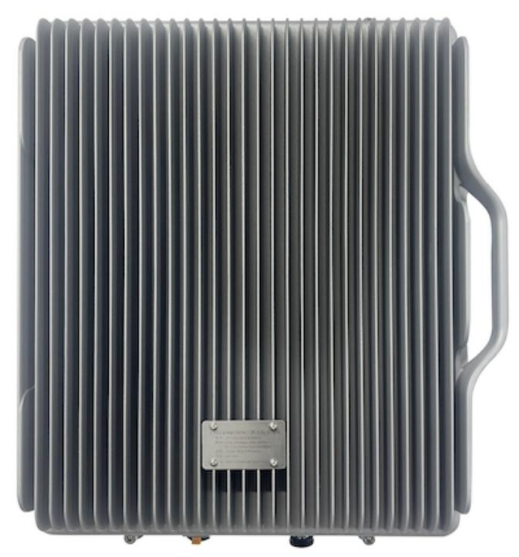
Tetra 412MHz Repeater System
Model: RF37-UHF412B

Product Features:
- LCD display the input/output signal strength.
- Auto isolation detection.
- Improve any three mobile networks at the same time.
- Built-in Auto Gain Control (AGC)& Auto Level Control (ALC).
- Center frequency movable.
- NMS Lite for remote/local control and monitoring(Optional)

Working Schematic Diagram
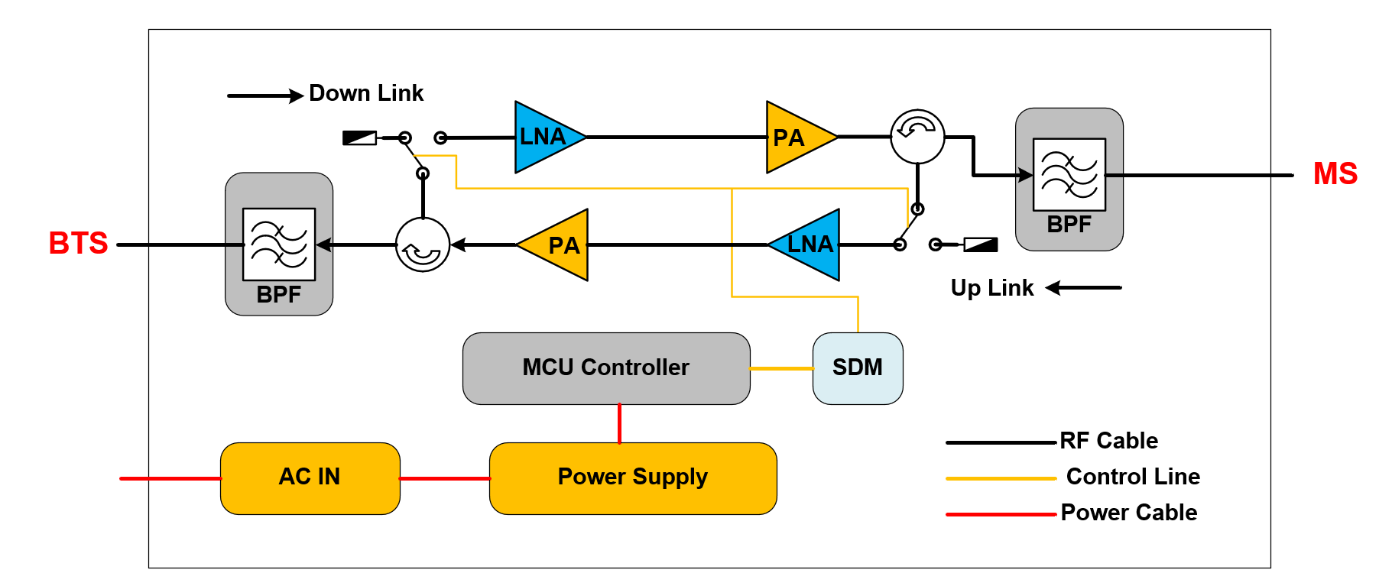
Application Scenario:
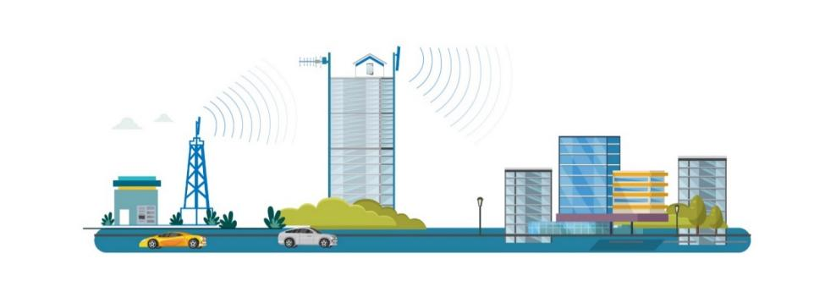

Technical Specifications:
Items |  | Specifications
System |  | VHF
Frequency Range | Uplink(Rx) | 412-417MHz
Frequency Range | Downlink(Tx) | 422-427MHz
Bandwidth |  | 5MHz
Maximum Output  Power | Uplink | 25±2dBm
Maximum Output  Power | Downlink | 37±2dBm
Maximum Gain |  | 90±3dB
AGC Range |  | ≥20dB
Maximum Input power(Non-Destructive) |  | ≤-10dBm
VSWR |  | ≤ 2.4
System Delay |  | ≤ 6 μs
I/O Impedance |  | 50 Ω
Noise Figure |  | ≤ 8dB
Spurious Emission |  | 9kHz~ 1GHz: ≤ -36dBm
 |  | 1GHz~ 12.75GHz:≤-30dBm
Third-order Inter-Modulation |  | ≤ -40dBm
RF Connector |  | 2*N-Female
Power Consumption |  | ≤ 350W
Power Supply |  | Input:AC100~ 240V, 50/60Hz
Dimensions |  | 512*461*232mm
Weight |  | ≤ 25kg
Alarm Monitoring System |  | Alarm for Uplink Self-Oscillation
Isolation Detection |  | Isolation Check During Boot Time
Operating Temperature |  | -25 ~ +50 °C
Application |  | Indoor or Outdoor(IP65)
Relative Humidity Range |  | ≤95%(Non condensing)
Mounting |  | Wall Mounting

